Project Design Phase-II

Data Flow Diagram & User Stories

|  |  |
| --- | --- |
| Date | 26 JUNE 2025 |
| Team ID | LTVIP2025TMID59454 |
| Project Name | LearnHub: Your Center for Skill Enhancement |
| Maximum Marks | 4 Marks |

# Data Flow Diagrams:

A Data Flow Diagram (DFD) is a traditional visual representation of the information flows within a system. A neat and clear DFD can depict the right amount of the system requirement graphically. It shows how data enters and leaves the system, what changes the information, and where data is stored.

Example: DFD Level 0 (Industry Standard)

# Example:

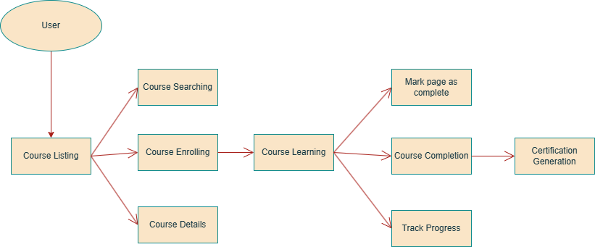

**User Stories**

Use the below template to list all the user stories for the product.

|  |  |  |  |  |  |  |
| --- | --- | --- | --- | --- | --- | --- |
| **User Type** | **Functional**  **Requirement (Epic)** | **User Story**  **Number** | **User Story / Task** | **Acceptance criteria** | **Priority** | **Release** |
| Educator | Account Management | USN-1 | As an educator, I can register for the application by entering my email, password, and confirming my password. | I can create an account easily | High | Sprint-1 |
| Educator | Course Creation  & Management | USN-2 | As an educator, I can create courses | I can create high quality  courses | High | Sprint-1 |
| Educator | Content Upload &  Structuring | USN-3 | As an educator, I can upload videos into my  course. Add chapters and pages to courses. | I can add chapters in  course, and pages in chapters | High | Sprint-2 |
| Learner | Course Discovery | USN-1 | As a learner, I can f ind latest technology courses | I can easily f ind latest courses | High | Sprint 1 |
| Learner | Flexible Learning Experience | USN-2 | As a learner, I should be able to learn f rom the comfort of my home | I can easily learn any course sitting in my home | High | Sprint 1 |
| Learner | Multilingual  Learning Support | USN-3 | As a learner, I should be able to learn courses  in any regional language | I can learn a course in any  language I want | Low | Sprint 2 |